THIS IS AN INDIVIDUAL ASSIGNMENT.

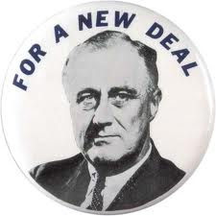
The G r e a t D e p r e $$i o n
A n d T h e N e w D e a l, 1929-1939
APUSH Review Guide for AMSCO chapter 24. Students who do not have the AMSCO guide may use Pearson chapter 22 or other resources for the Great Depression Era.

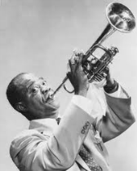
Directions Print document and take notes in the spaces provided. Read through the guide before you begin reading. This step will help you focus on the most significant ideas and information as you read.
Pictured at left: campaign button for Franklin Deleno Roosevelt, 1932, Public Domain

Learning Goals:
Identify and analyze the causes and effects of the Great Depression.
Analyze the ways Americans and government responded to the economic depression.
Assess the extent to which the New Deal successfully solved the problems facing Americans during the Great Depression.

Key Concepts FOR PERIOD 7:
Key Concept 7.1: Growth expanded opportunity, while economic instability led to new efforts to reform U.S. society and its economic system.
Key Concept 7.2: Innovations in communications and technology contributed to the growth of mass culture, while significant changes occurred in internal and international migration patterns.
Key Concept 7.3: Participation in a series of global conflicts propelled the United States into a position of international power while renewing domestic debates over the nation’s proper role in the world.

Guided Reading… Introduction, page 496

- After reading the first 3 paragraphs for chapter 24, explain the local and broad context of The Great Depression. Remember in your essay writing… the contextualization of your topic must be thoroughly explained with several sentences! Show that you have mastered this skill!

Local context… facts about the event, describing who/what/when etc.
Broad context… the bigger picture, theme, era, why/how

Causes and Effects of the Depression, 1929-1939, pp 496-498

- Prompt: Explain why business cycle fluctuations became increasingly severe, resulting in the Great Depression.
Main Ideas | Notes/Explanations/Definitions | Analysis
Answer: Even as economic growth continued, episodes of credit and market instability, most critically the Great Depression, led to calls for the creation of a stronger financial regulatory system.  - Stock Market Crash & Burn  -uneven distribution of income  -speculation & buying on margin  -buying on credit  -overproduction  -weak agricultural sector  -tight money policy of Fed.  -lack of regulation  -global economic problems  -Treaty of Versailles  b. Effects | Causes and Effects of the Depression, 1929-1939…  Wall Street Crash…  Black Thursday and Black Tuesday…  Causes of the Crash…  Uneven Distribution of Income…  Stock Market Speculation…  Excessive Use of Credit…  Overproduction of Consumer Goods…  Weak Farm Economy…  Government Policies…  Global Economic Problems…  Effects… | Explain why the causes of the Great Depression led to calls for government action and reform.  To what extent was idealism about American prosperity and the American dream responsible for the Crash? Defend your answer.  Of the effects discussed on pages 498-499, which one is the most significant in leading to dramatic and far-reaching reform in the next decade? Explain your reasoning.
Hoover’s Policies, pp 500-501

- Prompt: How did Hoover respond to the economic downturn?

Main Ideas | Notes/Explanations/Definitions | Analysis
Answer: National, state, and local reformers responded to economic upheavals, laissez-faire capitalism, and the Great Depression by transforming the U.S. into a limited welfare state. However, President Herbert Hoover did “too little too late” and was unsuccessful in providing effective government response to the crisis.  - Rugged individualism  - Increased tariffs  - Debt moratorium  - FFB  - RFC | Hoover’s Policies…  Responding to a Worldwide Depression…  Hawley-Smoot Tariff, 1930  Debt Moratorium…  Domestic Programs: Too Little, Too Late…  Federal Farm Board…  Reconstruction Finance Corporation (RFC)…  Despair and Protest…  Unrest on the Farms…  Bonus March…  The Election of 1932…  Democrats…  Results…  Hoover as “Lame-Duck” President… | Explain why the 20th Amendment was ratified.  Explain how Harding and Coolidge may have addressed the causes and issues that Hoover addressed “too little too late.”  Defend, Support, or Modify the following statement, “The Hawley-Smoot Tariff was the greatest example of modern stupidity since the American refusal to join the League of Nations.”

Franklin D. Roosevelt’s New Deal, pp 502-507

- Prompt: To what extent was Roosevelt’s New Deal an expansion of Progressivism?

Main Ideas | Notes/Explanations/Definitions | Analysis
Answer: The liberalism of President Franklin Roosevelt’s New Deal drew on earlier progressive ideas and represented a multifaceted approach to both the causes and effects of the Great Depression, using government power to provide relief to the poor, stimulate recovery, and reform the American economy.  - Fireside Chats  - First Hundred Days  -21ST Amendment  -Emergency Banking Relief Act  -Glass Steagel Act  / FDIC  -HOLC  -Farm Credit -Administration  Continued on next page… | Franklin D. Roosevelt’s New Deal…  FDR: The Man…  Disability…  Eleanor Roosevelt…  New Deal Philosophy…  Three R.’s:  Brain Trust and Other Advisers…  First Hundred Days…  Bank Holiday…  Repeal of Prohibition…  Fireside Chats…  Financial Recovery and Reform Programs…  . | Describe the significance of FDR’s ability to inspire people and Eleanor Roosevelt’s ability to empathize with people?  Why did Congress support every idea FDR had in the First Hundred Days despite them being radical change?  Of the Financial Reforms, which was the most significant long term? Defend your answer.
Main Ideas | Notes/Explanations/Definitions | Analysis
Prompt: To what extent was Roosevelt’s New Deal an expansion of Progressivism?  Answer Continued…  The liberalism of President Franklin Roosevelt’s New Deal drew on earlier progressive ideas and represented a multifaceted approach to both the causes and effects of the Great Depression, using government power to provide relief to the poor, stimulate recovery, and reform the American economy.  - RELIEF & RECOVERY  -FERA  -PWA  -CCC  -TVA  -NRA  -AAA  -CWA  -SEC  -FHA  -WPA  -RA  b. REFORMS  -Wagner Act  -REA  -Revenue Act  -Social Security  Act | Relief for the Unemployed…  Industrial Recovery Program…  Farm Production Control Program…  Other Programs of the First New Deal…  The Second New Deal…  Relief Programs…  The Election of 1936… | Were any of FDR’s actions during his First Hundred Days found to be unconstitutional? List and explain.  Was the Second New Deal better than the first? Explain your reasoning.

Opponents of the New Deal, pp 508-510

- Prompt: Analyze opposing viewpoints to the radical changes taking place in the United States government.

Main Ideas | Notes/Explanations/Definitions | Analysis
Answer: Radical, union, and populist movements pushed Roosevelt toward more extensive reforms, even as conservatives in Congress and the Supreme Court sought to limit the New Deal’s scope.  - Not Enough!  -Socialists  -extreme liberals  -women  -minorities  -Father Charles E. Coughlin  -Dr. Francis E. Townsend  -Huey Long  - Too Much!  -business  -American Liberty League  -Supreme Court (at first) | Opponents of the New Deal…  Liberal Critics…  Conservative Critics…  Demagogues…  Father Charles E. Coughlin…  Dr. Francis E. Townsend…  Huey Long…  The Supreme Court…  Court Reorganization Plan…  Reaction…  Aftermath… | Support, Refute, or Modify the following statement: The New Deal was revolutionary because it created a much more powerful central government, increased power to the executive branch, and began the modern welfare state. (skip to page 514 and read “Historical Perspectives” before answering.)  Defend your viewpoint with specific evidence.  In response to FDR’s Court Reorganization Bill Sen. Burton K. Wheeler (D-Montana) said, "Every despot has usurped the power of the legislative and judicial branches in the name of the necessity for haste to promote the general welfare of the masses—and then proceeded to reduce them to servitude."  Support, Refute, or Modify the following statement: Checks and Balances successfully prevented Franklin Roosevelt from becoming a tyrant.  Trivia Break:  Following the Court Packing plan, the swing vote of Justice Owen Roberts, began supporting the New Deal; called the "switch in time that saved nine."
Rise of Unions, pp 510-511

- Prompt: Evaluate the ways the New Deal impacted labor?
Highlight Main Ideas in the Background notes, read the pages, then record your notes and analysis below.

Background/Review… In the early 20th century, union membership rose to 6% of the labor force. There were 2.7 million members by 1913, and the share stayed around 6–7% until 1917. This was the "Progressive Era" of 1900 through 1918 which fastened a welfare-warfare state on America which has set the mold for the rest of the twentieth century. From 1842 onward, unions had the clear legal right to exist, and workers could join such "self-help" organizations, but employers were under no obligation to "bargain" with these unions. The courts also tended (ultimately) to restrict union tactics such as threats of violence, violence itself, mob action, and interference with voluntary trade. Further, the courts tended to make little distinction between business and union "restraints on competition." In 1912, Congress supplied new assistance with the Lloyd-LaFollette Act to compel collective bargaining by the US Post Office and encourage postal-union membership. In 1914, Congress passed the Clayton Anti-Trust Act with provisions to exempt unions from the 1890 Sherman Anti-Trust Act, restrict the use of court injunctions in labor disputes and declare picketing and similar union tactics as not unlawful. Samuel Gompers hailed the Clayton Act as labor's Magna Carta, but subsequent court interpretations neutered the pro-union provisions. The "national emergency" of US entry into World War I provided much of the experience and precedent for subsequent intervention on behalf of unionism, as well as for other cartel-like policies. Historian William E. Leuchtenburg, for instance, points out, "The panoply of procedures developed by the War Labor Board and the War Labor Policies Board provided the basis in later years for a series of enactments culminating in the Wagner National Labor Relations Act of 1935." Under pressure of World War I and the government's interventions, union membership skyrocketed, hitting 12% of the labor force. The end of the war ended pro-union interventions. By 1924, the union share of the labor force had slipped to 8%, and by 1933 had eroded to the same 6% as thirty years before.

Main Ideas | Notes/Explanations/Definitions | Analysis
Answer: Although the New Deal did not completely overcome the Depression, it left a legacy of reforms and agencies that endeavored to make society and individuals more secure, and it helped foster a long-term political realignment in which many ethnic groups, African Americans, and working-class communities identified with the Democratic Party. | Rise of Unions…  Formation of the CIO…  Strikes…  Automobiles…  Steel…  Fair Labor Standards Act…  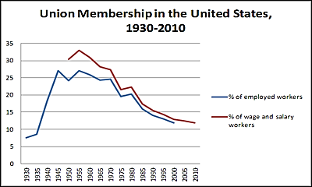 | Consider the bulk of the New Deal.  Would Woodrow Wilson approved?  To what extent was FDR continuing the legacy of Theodore Roosevelt and Woodrow Wilson? Explain and defend your answer.  Why has union member ship declined in recent eras? Ask your parents!  (or Siri)
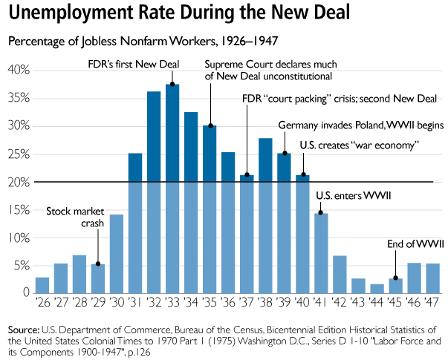

Last Phase of the New Deal, pp 511-512
- Prompt: Evaluate the success (positive impact) of the New Deal.
Main Ideas | Notes/Explanations/Definitions | Analysis
Answer: Although the New Deal did not completely overcome the Depression, it left a legacy of reforms and agencies that endeavored to make society and individuals more secure, and it helped foster a long-term political realignment in which many ethnic groups, African Americans, and working-class communities identified with the Democratic Party.  The mass mobilization of American society to supply troops for the war effort and a workforce on the home front ended the Great Depression and provided opportunities for women and minorities to improve their socioeconomic positions.  Therefore, the New Deal did not succeed in ending the Great Depression, but it did succeed in re-defining the role of government. | Last Phase of the New Deal…  Recession, 1937-1938…  Causes…  Keynesian Economics…  Weakened New Deal… | List three reasons the economy took another downturn (recession of 1937-1938)?  a.  b.  c.  What ended the Great Depression?

Life During the Great Depression, pp 512-513

- Prompt: Analyze the impact of the Great Depression on various groups.

Main Events/Ideas | Definitions/Explanations | Analysis
Answer: Americans who lived through the Great Depression were impacted in profound ways both economically and emotionally.  Many Americans migrated during the Great Depression, often driven by economic difficulties, and during World Wars I and II, as a result of the need for wartime production labor.  Many Mexicans, drawn to the U.S. by economic opportunities, faced ambivalent government policies in the 1930s and 1940s.  - “Depression Mentality”  - Women  -family  -discrimination  -help from New Deal  - Farmers  -Dust Bowl  -jobs  - help from New Deal  - African Americans  -discrimination  -help from New Deal  -social improvements  - Native Americans  -discrimination  -help from New Deal  -social improvements  - Mexican Americans  -discrimination  -Dust Bowl | Life During the Depression…  Women…  Dust Bowl Farmers…  African Americans…  Improvements…  Fair Employment Practices Committee…  American Indians…  Indian Reorganization (Wheeler-Howard) Act (1934)…  Mexican-Americans… | Explain the role First Lady, Eleanor Roosevelt, and Secretary of Labor, Francis Perkins, had in New Deal policies.  Analyze the contributions of Mary McLeod Bethune and the “Black Cabinet,” (Bethune was appointed by FDR to the director of the Office of Minority Affairs in the National Youth Administration).
- Analyze the following primary sources by identifying historical context and purpose or POV. Record your notes to the right of each image.

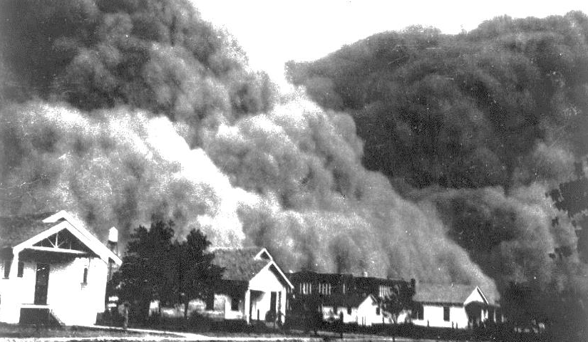
Photograph of dust cloud enveloping neighborhood, 1933

“Let the workers organize. Let the toilers assemble. Let their crystallized voice proclaim their injustices and demand their privileges. Let all thoughtful citizens sustain them, for the future of Labor is the future of America.”
John L. Lewis, CIO Chairman

