THIS IS AN INDIVIDUAL ASSIGNMENT.

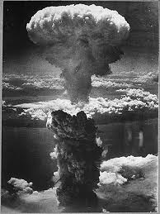
Name:________________________________________ Class Period:_____

FDR & WWII
APUSH Review Guide for AMSCO chapter 25. (and portions of other chapters as noted in reading guide)
Students without the 2015 edition of AMSCO should refer to Pearson chapter 23 or other resources.

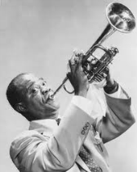
Directions Print document and take notes in the spaces provided. Read through the
guide before you begin reading. This step will help you focus on the most significant ideas
and information as you read. This guide can earn bonus points for going above and beyond.
. Pictured at right: nuclear explosion over Nagasaki, 1945, Public Domain

Learning Goals:
Compare FDR’s policies to those of Woodrow Wilson and the Roaring Twenties’ presidents.
Identify and analyze the causes and effects of the World War II.
Analyze the ways Americans and government responded to war, and evaluate WWI as a major turning point in United States history.

Key Concepts FOR PERIOD 7:
Key Concept 7.1: Growth expanded opportunity, while economic instability led to new efforts to reform U.S. society and its economic system.
Key Concept 7.2: Innovations in communications and technology contributed to the growth of mass culture, while significant changes occurred in internal and international migration patterns.
Key Concept 7.3: Participation in a series of global conflicts propelled the United States into a position of international power while renewing domestic debates over the nation’s proper role in the world.

Section 1: Reviewing Post WWI Foreign Policies and evaluating their impact. (read pages referenced in chart before completing each row)
Answer the following questions by reviewing main events, defining terms, and analyzing significance in the spaces provided.
- Analyze the reasons why WWI was not “the war to end all wars,” as Woodrow Wilson had hoped. Define and explain each policy in detail, and review the analysis of “why it didn’t work.” Highlight main ideas.
Policies | Definitions and Explanations… | Why it didn’t work…
Treaty of Versailles  see pp 465-466  and page 525 |  | The Treaty of Versailles was not ratified by the United States mainly over Wilson’s refusal to compromise on the League of Nations and the irreconcilable sin Congress refusing to agree to any sort of “entangling alliance.” Issues over other Treaty provisions such as punishment of Germany (economic, geographic, military, and emotional) caused reservations among some American leaders. This treaty was largely seen as a major cause of WWII as it didn’t solve the problems of WWI and contributed to more problems which further disrupted balance of power and the global economy.
League of Nations  see page 464 |  | The League of Nations was created following WWI, but the United States did not join. The United States was, in the 1920s, one of the most powerful and influential nations in the world, and not taking a leadership position in this new diplomatic organization doomed it to failure (especially when you combine it with the Treaty of Versailles provisions). When trouble arose in the 1920s with fascism in Italy and then militarism in Japan (followed by fascism in Germany in the 1930s), the League of Nations was unable and unwilling to take a strong stand against new empires which allowed the Axis Powers to form and begin their world domination plots with little interference from League nations (and the U.S.)

Section 1 Continued…
Analyze the reasons why WWI was not “the war to end all wars,” as Woodrow Wilson had hoped. Define and explain each policy in detail, and review the analysis of “why it didn’t work.” Highlight main ideas.
Policies | Definitions and Explanations… |  |  | Why it didn’t work…
Washington Naval Conference and subsequent treaties:  5-Power,  4-Power, &  9-Power Treaties  see pp 486-487 |  |  |  | After the Great War, the United States made a separate peace with Germany and then began its own, independent efforts to prevent future war. This conference had a goal of promoting disarmament and restoring balance of power. President Harding and Secretary of State Charles Evans Hughes successfully negotiated these three treaties; however, Italy and Japan (signers of some of these treaties) did not follow through.
Kellogg-Briand Pact  see page 487 |  | President Calvin Coolidge and Secretary of State Frank Kellogg led a multi-nation effort to prevent war with this treaty, however it was just as idealistic (perhaps more so) than Wilson’s Fourteen Points. It failed simply because the world isn’t full of peace-loving pacifists, and outlawing war even with 62 nations (including Germany) signing it. Jane Addams won the Nobel Peace Prize in 1931 for her efforts in promoting such strategy for peace, this while Hitler was rising to power in Germany. It is a classic example of lovely idealism amidst ugly realism.
Dawes Plan  see page 488 |  |  | Vice President Charles Dawes (under President Coolidge) developed this plan in order to keep reparation payments flowing to the Allies (Treaty of Versailles) which would then allow the Allies to continue to pay back WWI loans to the United States. It temporarily succeeded in easing economic pressure in Europe, but ultimately failed due to the global depression which began in 1929. This plan’s alternative was debt forgiveness, which in hindsight may have been a better strategy.
Stimson Doctrine  see page 522 |  |  | President Herbert Hoover, the last of three Republican presidents of the Roaring Twenties, continued the post-Wilson tradition of “isolationism” (although isolationism was flawed and not completely a reality since the United States was heavily involved in foreign diplomacy and economics). Hoover and Secretary of State Henry Stimson issued this doctrine in ho pes of avoiding war but it was nothing more than a verbal and written condemnation of Japanese aggression. Militaristic empires usually don’t pay attention to pacifists.

Section 1 Closure Questions
What did President Woodrow Wilson, 1913-1921 and President Herbert Hoover, 1929-1933 have in common when it came to foreign policy?

How did they differ?

To what extent was the United States isolationist in the 1920s? Explain your reasoning with one specific piece of evidence.

Section 2 Guided Reading, Diplomacy and World War II, 1929-1945, pp 521-540

From Hoover to FDR, pp 521-526

- Evaluate the effectiveness of Franklin Roosevelt’s foreign policies from 1933-1938.

Main Ideas | Definitions/Explanations/Notes | Analysis
In the years following World War I, the United States pursued a unilateral foreign policy that used international investment, peace treaties, and select military intervention to promote a vision of international order, even while maintaining U.S. isolationism, which continued to the late 1930s.  …continued on next page… | Diplomacy and World War II, 1929-1945, chapter introduction…  Herbert Hoover’s Foreign Policy…  Japanese Aggression in Manchuria…  Stimson Doctrine… (defined on page 2 of this guide already)  Latin America…  Franklin Roosevelt’s Policies, 1933-1938…  Good-Neighbor Policy…  Pan-American Conferences…  Cuba…  Mexico…  Economic Diplomacy…  Recognition of the Soviet Union… | How did Hoover differ from Progressive Era foreign policy? Defend your answer with specific evidence.  How did FDR differ from Progressive Era foreign policy? Defend your answer with specific evidence.
Main Ideas | Definitions/Explanations/Notes | Analysis
…continued from previous page…  In the years following World War I, the United States pursued a unilateral foreign policy that used international investment, peace treaties, and select military intervention to promote a vision of international order, even while maintaining U.S. isolationism, which continued to the late 1930s.  …continued on next page… | Philippines…  Reciprocal Trade Agreements…  Events Abroad: Fascism and Aggressive Militarism…  Italy…  Germany…  Japan…  American Isolationists…  The Lessons of World War I… | Explain the goals of U.S. policy makers as they implemented these policies during the 1930s?  Explain the role Senator Gerald Nye played in leading American down a path of isolationism?
Main Ideas | Definitions/Explanations/Notes | Analysis
…continued from previous page…  In the years following World War I, the United States pursued a unilateral foreign policy that used international investment, peace treaties, and select military intervention to promote a vision of international order, even while maintaining U.S. isolationism, which continued to the late 1930s. | Neutrality Acts…  The Neutrality Act of 1935…  The Neutrality Act of 1936…  The Neutrality Act of 1937…  Spanish Civil War…  America First Committee…  Prelude to War…  Appeasement…  - Ethiopia, 1935  - Rhineland, 1936…  - China, 1937…  - Sudetenland, 1938…  Quarantine Speech…  Preparedness… | How did American Identity in the years leading up to WWII mimic identity leading up to WWI?  Explain how each of the Neutrality Acts illustrate a lesson learned from WWI.  1935:  1936:  1937:  Was the policy of appeasement compatible with Woodrow Wilson’s Fourteen Points? Explain your reasoning.
From Neutrality to War, 1939-1941, pp 527-531

- Explain why the United States to change its foreign policy from neutrality to interventionism.

Main Ideas |  | Definitions/Explanations/Notes | Analysis
The involvement of the United States in World War II, while opposed by most Americans prior to the attack on Pearl Harbor, vaulted the United States into global political and military prominence, and transformed both American society and the relationship between the United States and the rest of the world.  …continued on next page… |  | From Neutrality to War, 1939-1941…  Outbreak of War in Europe…  Invasion of Poland…  Blitzkrieg…  Changing U.S. Policy…  “Cash and Carry”…  Selective Service Act (1940)…  Destroyers-for-Bases Deal…  The Election of 1940…  Wendell Willkie…  Results… | Explain why FDR’s foreign policy began to change from isolationism to interventionism as illustrated in his polices prior to the attack on Pearl Harbor.  Why did Franklin Roosevelt decide to run for a third term? Was he the first to do so? Why was it so controversial?
Main Ideas | Definitions/Explanations/Notes |  | Analysis
…continued from previous page…  The involvement of the United States in World War II, while opposed by most Americans prior to the attack on Pearl Harbor, vaulted the United States into global political and military prominence, and transformed both American society and the relationship between the United States and the rest of the world.  Global conflicts over resources, territories, and ideologies renewed debates over the nation’s values and its role in the world, while simultaneously propelling the United States into a dominant international military, political, cultural, and economic position. | Arsenal of Democracy…  Four Freedoms…  Lend-Lease Act…  Atlantic Charter…  Shoot –on-Sight…  Disputes with Japan…  U.S. Economic Action…  Negotiations…  Pearl Harbor…  Partial Surprise…  Declaration of War…  Soviet Union Invaded… |  | Compare Americans’ reaction to the bombing of Pearl Harbor to their reaction to the Zimmerman Note.  Explain the significance of this comparison.

World War II: The Home Front, pp 531-535
- Analyze the ways Americans responded to and contributed to the war effort on the home front.

Main Ideas | Definitions/Explanations/Notes | Analysis
The mass mobilization of American society to supply troops for the war effort and a workforce on the home front ended the Great Depression and provided opportunities for women and minorities to improve their socioeconomic positions.  …continued on next page… | World War II: The Home Front…  Mobilization…  Federal Government…  Business and Industry…  Research and Development…  Workers and Unions…  Financing the War…  Wartime Propaganda… | Compare the WPB and OWM to the 1918 War Industries Board and National War Labor Board. (see pages 460-461 to review WWI events)  How were they similar?  How were they different?  Compare the Office of War Information to the WWI Committee on Public Information (see page 461).  How were their propaganda pieces similar?  How were they different?  What impact did this mobilization have on the unemployment rate?

Main Ideas | Definitions/Explanations/Notes | Analysis
…continued from previous page…  The mass mobilization of American society to supply troops for the war effort and a workforce on the home front ended the Great Depression and provided opportunities for women and minorities to improve their socioeconomic positions.  Wartime experiences, such as the internment of Japanese Americans, challenges to civil liberties, debates over race and segregation, and the decision to drop the atomic bomb raised questions about American values.  …continued on next page… | The War’s Impact on Society…  African Americans…  Mexican Americans…  American Indians…  Japanese Americans…  Women…  Wartime Solidarity… | Explain how U.S. involvement in WWII set the stage for domestic social changes. Consider each group mentioned in this section, and explain your reasoning for each group.

Main Ideas | Definitions/Explanations/Notes | Analysis
…continued from previous page… | The Election of 1944…  Again, FDR…  Thomas Dewey…  Results… | Some critics of FDR’s New Deal felt he was becoming too powerful and even tyrannical as he increased the size of the government and challenged the balance of power with his court packing plan. Did this election ease or intensify their critique? Explain your reasoning.

World War II: The Battlefronts, pp 535-537

- Explain how the Allies defeated the Axis Powers, and evaluate the effectiveness of American troops and foreign policies.

Main Ideas | Definitions/Explanations/Notes | Analysis
The United States and its allies achieved victory over the Axis powers through a combination of factors, including allied political and military cooperation, industrial production, technological and scientific advances, and popular commitment to advancing democratic ideals.  …continued on next page…  …continued from previous page…  The United States and its allies achieved victory over the Axis powers through a combination of factors, including allied political and military cooperation, industrial production, technological and scientific advances, and popular commitment to advancing democratic ideals. | World War II: The Battlefronts…  Fighting Germany…  Defense at Sea, Attacks by Air…  From North Africa to Italy…  From D-Day to Victory in Europe…  German Surrender and Discovery of the Holocaust…  Fighting Japan…  Turning Point, 1942…  Island-Hopping…  Major Battles…  Atomic Bombs…  Japan Surrenders… | How did discovery of the Holocaust impact Americans?  Why do many modern day people doubt whether or not the Holocaust occurred? (You may need to investigate this on the Internet if you are not familiar with Holocaust denial.)  Explain the role of technology in the WWII victory.  Compare the kamikaze pilots of WWII to the suicide bombers of the modern War on Terror. What is significant about this comparison?

Wartime Conferences, pp 537-538

- Explain how and why U.S. foreign policy changed from isolationism to interventionism as a result of WWII.

Main Ideas | Definitions/Explanations/Notes | Analysis
The dominant American role in the Allied victory and postwar peace settlements, combined with the war-ravaged condition of Asia and Europe, allowed the United States to emerge from the war as the most powerful nation on earth. | Wartime Conferences…  Casablanca…  Tehran…  Yalta…  Death of President Roosevelt…  Potsdam… | In what ways were these conferences aimed at ending the war, and in what ways were they aimed at preventing another war? Explain your answer.

The War’s Legacy, pp 538-539

- Compare the legacy of WWII to the legacy of WWI.

Main Ideas | Definitions/Explanations/Notes
Global conflicts over resources, territories, and ideologies renewed debates over the nation’s values and its role in the world, while simultaneously propelling the United States into a dominant international military, political, cultural, and economic position. | The War’s Legacy…  Costs…  The United Nations…  Expectations…

Have you resolved your Roosevelt Confusion yet?

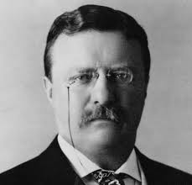
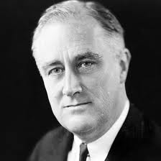
Franklin Delano Roosevelt, FDR
President from 1933-1945
New Deal, WWII
Not to be confused with…
Theodore “Teddy” Roosevelt
President from 1901-1909
Imperialism, Progressive Era

- Analyze the following paintings.
Taken from Franklin Roosevelt's 1941 speech to Congress, the "Four Freedoms" --Freedom of Speech, Freedom of Worship, Freedom from Want, and Freedom from Fear--became a rallying point for the United States during WWII.
Artist Norman Rockwell created four vignettes to illustrate the concepts. Rockwell intended to donate the paintings to the War Department, but after receiving no response, the painter offered them to the Saturday Evening Post, where they were first published on February 20, 1943.
Popular reaction was overwhelming, and more than 25,000 readers requested full-color reproductions suitable for framing.
Identify and analyze the symbolism and meaning of each painting.

What do these paintings illustrate about American Identity?

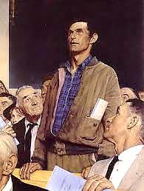
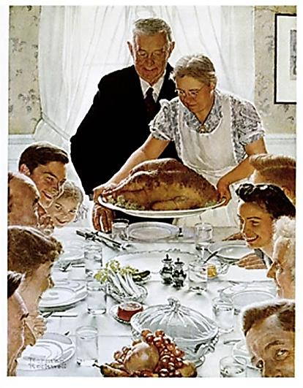

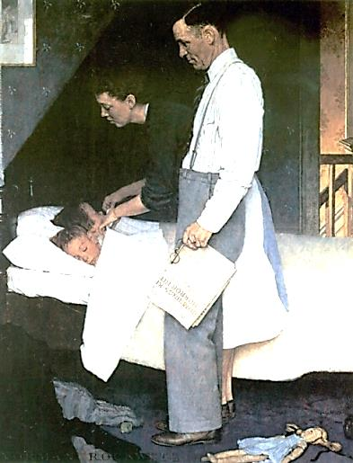
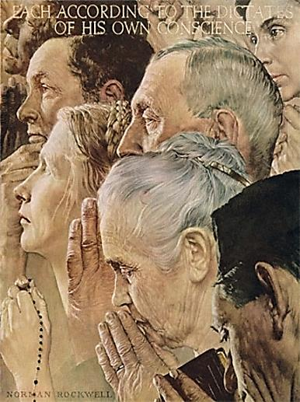
Read Historical Perspectives on page 540, then address the following prompt: Support, Refute, or Modify the following statement: The United States could have prevented WWII. Defend your answer with specific evidence.
- Identify the purpose of WWII propaganda samples.

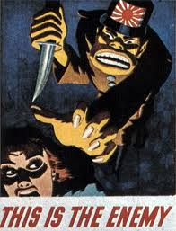
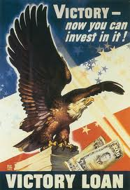
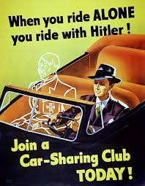
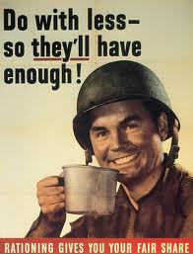
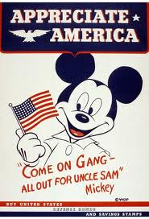
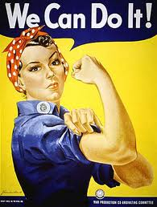

Reading Guide written by Rebecca Richardson, Allen High School
Sources include but are not limited to: 2015 edition of AMSCO’s United States History Preparing for the Advanced Placement Examination,
2012 and 2015 Revised College Board Advanced Placement United States History Framework, images from WikiCommons, ushistory.org, and other sources as cited in document and collected/adapted over 20 years of teaching and collaborating

